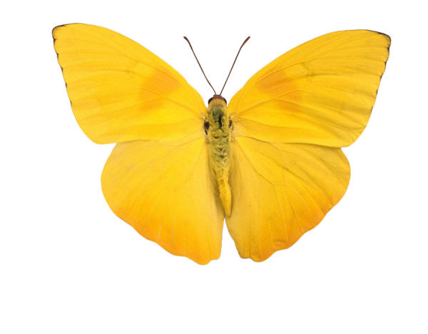

Ben Baxter  
Comp 2230  
T00032663

Assignment 4

A study in Iterable



# Problem Definition

**Problem 1**

**LinkedList needs to implement Iterator and have its own Inner iterator class. modCount needs to be maintained across the class for iterator error checking.**

**Problem 2**

**LinkedQueue needs to implement Iterator and have its own Inner iterator class. modCount needs to be maintained across the class for iterator error checking.**

**Problem 3**

**CircularArrayQueue needs to implement Iterator and have its own Inner iterator class. modCount needs to be maintained across the class for iterator error checking.**

* **See code comments for Pre/Post and Big 0**

**Uml**

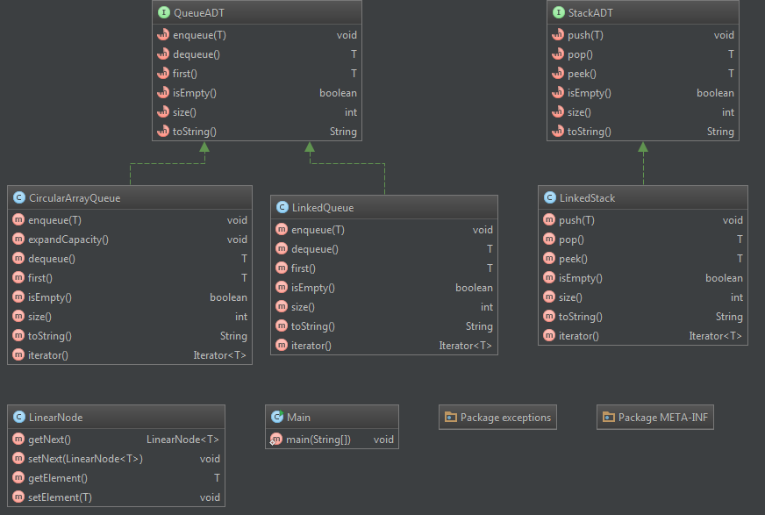

**Output**

